YOGASANAS IN SITTING POSITION
DHYANA MUDRA :
This mudra is also called dhyana mudra. But then that seems to be the distorted form of dhyana mudra. In this position, the palms are open. The tips of the thumbs and index fingers are brought together forming a circle. The remaining three fingers of both hands should be kept together and relaxed. Holding this position with both hands is called dhyana mudra. This mudra is to be taken in sitting posture, and the wrists are to be kept on the respective knees and the palms facing upward.
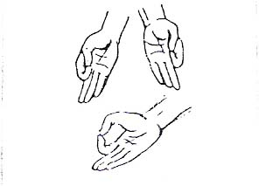

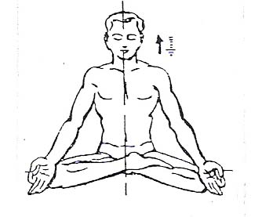

SWASTIKASANA
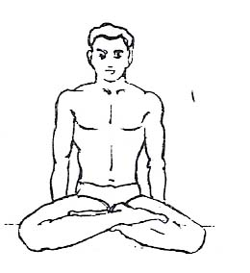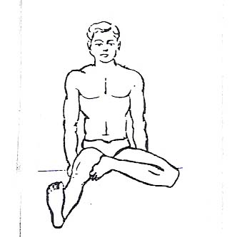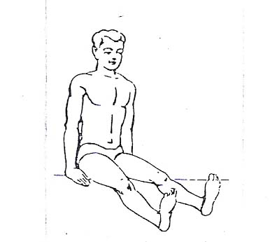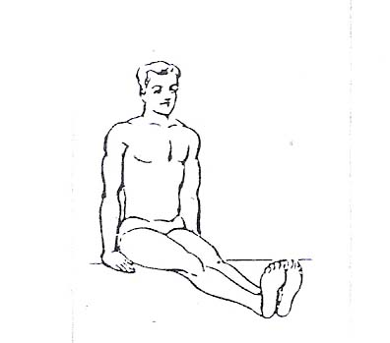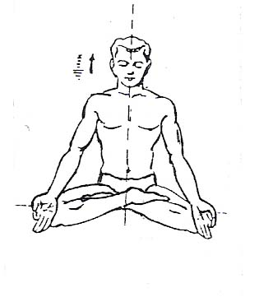
Introduction:
In this asana, one leg is placed on the other leg in a particular way and then the position is stabilized. Since ancient times, this posture has been taken to be auspicious, which is why it is called swastika. Therefore, this asana is called "swastikasana'Taking the Asana Position:
Initial Position : Sitting Position
1) Spread both the legs, keeping them at about hips width apart..
2) Bend the left leg at the knee placing the sole of the foot against the inner side of the right thigh.
3) Bend the right leg at the knee placing the foot between the thigh and calf of the left leg.
4) Keep the wrists of both hands on the respective knees and take dhyana mudra. Continue breathing smoothly.

The Asana Position :
In this asana the position of the body is stabilized by the position of the legs. Keep the backbone erect and gaze forward. One can maintain this position for a long time. Of course, it needs some practice. This asana is used for dhyana-dharana, i.e. meditation and concentration.
Releasing the Asana Position :
1) Bring the hands back to the floor, next to your hips
2) Straighten the right leg in front, with no bend in the knee.
3) Straighten the left leg in front, with no bend in the knee.
4) Bring both legs together and take the sitting position.
Duration :
Within 10-12 days' of practicing this asana, one should be able to maintain it for 10 minutes. After more practice, the length of time held can be increased to two to three hours. Sitting for a long time in this asana alone allows one to experience its pleasure and benefits.
Internal Effects :
As the backbone is kept erect, its function can be greatly improved. dhyana mudra further helps in stabilizing the heart rate. Consequently, the strain on many muscles of the body is reduced and this in turn helps reduce the strain on the heart. Breathing in turn slows down, allowing for better concentration of the mind. Therefore, this asana is used for pranayama and dhyana-dharana.
Precautions:
As this asana is very easy, there are no precautions.

SAMASANA
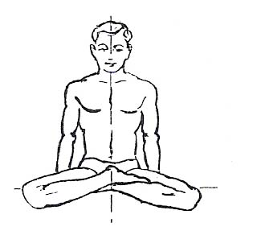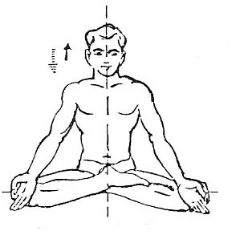
Introduction:
In this asana, the external organs of the body are kept in such a way that they stand divided into two, and hence the name "samasana'. In some yoga books it is called "guptasana'.
Taking the Asana Position:
Initial Position : Sitting Position
1) Spread the extended legs and keep them at a distance of one or one and a quarter feet.
2) Bend the left leg at the knee and place it against the inner thigh of the right leg, in such a way that the heel presses against the groin area.
3) Bend the right leg at the knee and place it on the left leg in such a way that its heel is placed on top of the heel of the left leg.
4) Keep both hands on the knee and take dhyana mudra.

The Asana Position:
In this asana, the spine is kept erect, the knees in a straight line and the eyes closed or fixed ahead. Continue smooth breathing.
Releasing the Asana Position :
1) Bring the hands back to the floor, next to your hips.
2) Straighten the right leg in front, with no bend in the knee.
3) Straighten the left leg in front, with no bend in the knee.
4) Bring both legs together and take the sitting position.
Duration :
Since this asana is also used for pranayama, meditation and concentration, it can be maintained for hours. Normally, it should be kept for ten minutes in order to gain the benefits.
Internal Effects :
The same as stated for swastikasana.
Precautions :
People suffering from hydrocele or enlargement of testicles should not practice this Asana.

PADMASANA
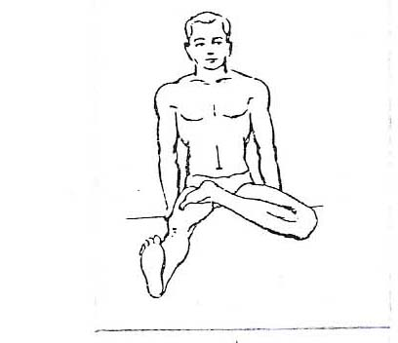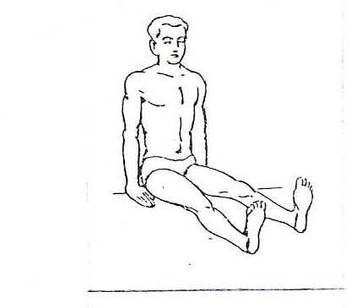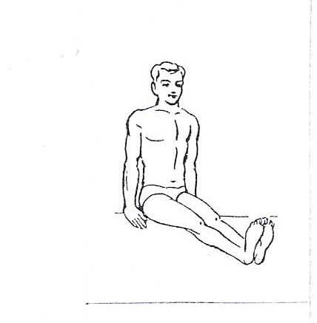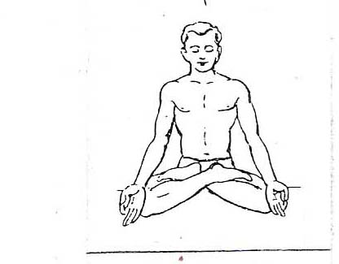

Introduction:
"Padma' means lotus. This is because, in this asana, the position of the feet looks like a blooming lotus. This asana has been given great importance in the Yogashastra, and is considered the best asana for meditation, concentration and pranayama.

Taking the Asana Position:
Initial Position : Sitting Position
1) Spread the legs and place them at a distance of about one or one and a half feet from each other.
2) Bend the right leg at the knee and place the toes on the thigh and the heel on the groin of the left leg.
3) Bend the left leg at the knee and place the toes on the thigh and the heel on the groin of the right leg.
4) Keep both hands on the knees and take up dhyana mudra; continue breathing smoothly.
The Asana Position :
In this asana, the head, the neck and the spine are kept in a straight line and the eyes look straight ahead, while the breathing continues smoothly. The hands in dhyana mudra rest on the knees without pressure of any kind. If the arms are long, they can be slightly bent in the elbows. The arms can be kept straight also but they should not be strained in any way. The weight of the whole body should be on the spine. The knees will have a tendency to rise in this asana, but they should be kept as close to the floor as possible.
Releasing The Asana Position :
1) Bring the hands back to the floor, next to your hips.
2) Straighten the left leg in front, without bending the knee.
3) Straighten the right leg in front, without bending the knee.
4) Bring both legs together and take the sitting position.
NOTE: Here it is said to first bend the left leg at the knee and place the toes on the thigh of the right leg. However, the old yoga texts suggest bending the right leg first. Yet no difference has been found between starting with the left or right leg...
Duration :
After adequate practice, it can be held for three to four hours. But normally this asana should be maintained for at least ten minutes to experience its benefits.

Internal Effects :
This asana stabilizes not only the body but also the mind. Therefore, it is chiefly used for meditation, concentration (dhyana-dharana) and pranayama. This asana is also used as the initial position for certain other asanas, e.g. sharanagata mudra, utthita padmasana, etc.
Precautions :
On certain occasions one is asked to have jalandhar bandha and mul bandha in this asana. The asana should be tried only after good knowledge and practice of those bandhas. It can put stress on the knees and ankles, and thus the practitioner should be careful if they have had previous injury to the knees and/or ankles.
BADDHA PADMASANA
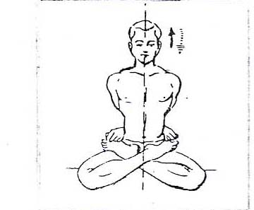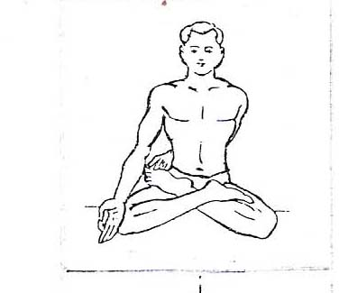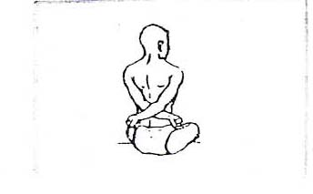
Introduction :
Sitting in padmasana, instead of having the hands in dhyana mudra, they are used to hold the big toes of the feet. The otherwise free padmasana position gets tied here, hence the name baddha padmasana.
Taking Asana Position:
Initial Position : Sitting Position
1) The left hand comes around the back and holds the big toe of the left foot, which is resting on the thigh of the right leg.
2) The right hand comes around the back and holds the big toe of the right foot, which is resting on the thigh of the left foot.
The Asana Position :
While holding the big toes of both feet, straighten the spine. While holding the toes, the padmasana position should be held steadily. Gaze forward and continue breathing smoothly.
Duration :
When first starting to practice this asana, one may find it difficult. But as it becomes possible to take up this asana, it should be held for up to thirty seconds. There is no point in increasing its duration beyond thirty seconds.
Precaution :
This asana places tremendous pressure on the abdomen, therefore, people suffering from abdominal troubles or having undergone surgery in the abdominal region should only practice this asana after consulting a yoga expert.
UTTHITA PADMASANA
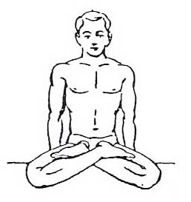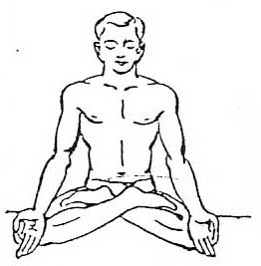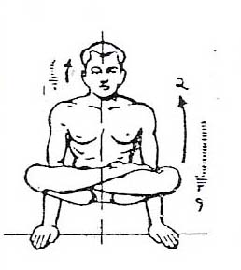
Introduction :
In this asana the whole body in padmasana is lifted up with the help of the hands, and therefore it is called utthita padmasana. All of the body weight is placed on the hands and so it is called "tolasana'. But the latter name is not used anymore
Taking the Asana Position:
Initial Position : Padmasana Position
1) Release the dhyana mudra of the hands and bring them back to the floor, next to your hips, as in the sitting position.
2) Exhale, and while inhaling, lift the whole body with the help of the hands and stabilize this position. Keep breathing smoothly.
The Asana Position:
While lifting the padmasana, do not allow the knees to come down. It is very important to stabilize this asana. In order to maintain the balance, keep the shoulders slightly backward. Gaze forward.
Releasing the Asana Position :
1) Inhale, and while exhaling, lower the body to the floor slowly.
2) Put both hands on the knees and restore dhyana mudra.
Duration :
Since all of the body weight is placed on the hands, and must be balanced on the hands, this asana should be maintained for up to thirty seconds or so. There is no point in increasing the duration.
Internal Effects :
In addition to the advantages of padmasana, it has a good effect on the intestines and the muscles of the body by putting pressure on them.
Precaution :
While lifting the body on the hands, one may lose balance and fall backward; so focus carefully.
PARVATASANA
Introduction :
The body in this asana looks like the shape of a mountain peak and hence it is called parvatasna.
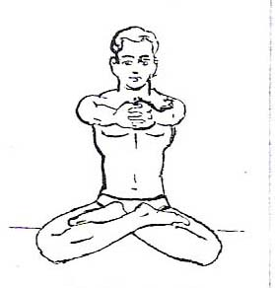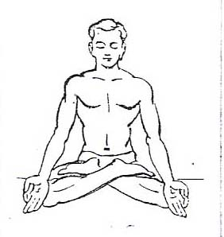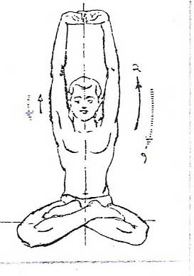

Taking the Asana Position:
Initial Position : Padmasana Position
1) Lift both of the arms straight out from the body to hold at shoulder level, and then clasp the fingers with both hands.
2) Take the clasped hands over the head, then turn the palms up and stretch the body upward with the help of the arms. Stabilize the position and continue breathing smoothly.
The Asana Position :
In this asana it is necessary to lengthen the body upward. The body is not lifted up, but rather the muscles of the arms, the back and the abdomen are stretched through the lengthening of the spine.
Releasing the Asana Position :
1) Relax the body and bring the hands in position No.1 above.
2) Keep the hands on the knees and take dhyana mudra.
Duration :
This asana can easily be maintained for a longer time without any trouble if one is comfortable in padmasana.
Internal Effects :
Stretches the muscles of the arms, back and abdomen, and improves their function. It also improves the function of the spinal cord and helps to cure certain spinal cord and column problems.

Precautions :
There are no precautions as this asana is quite simple.

AAKARNA DHANURASANA (TYPE-1)
Introduction :
We have already seen that the asana in which the body looks like a bow is called "dhanurasana'. And we have discussed this asana in prone position. In dhanurasana, the body gets stretched like the string of a bow does when drawn back before releasing an arrow.
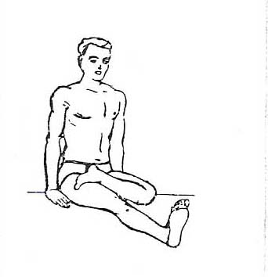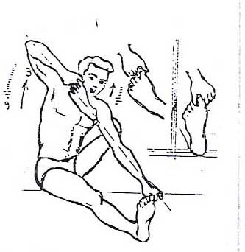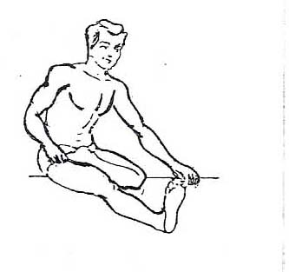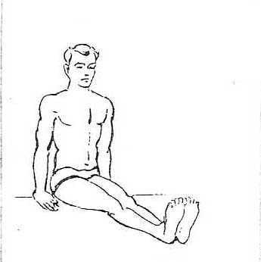
Taking the Asana Position:
Initial Position : Sitting Position
1) Bend the left leg at the knee and keep the foot on the thigh of the right leg. Keep the right leg straight.
2) Hold the big toe of the left leg with right hand, and with the left hand hold the big toe of the right leg between the thumb and index finger, and the other three fingers with a good grip of the thumb.
3) Exhale, and while inhaling start lifting the left foot with the right hand and pull it up to the ear. Keep the back and the neck erect and the gaze fixed on the other end of the left hand. Continue breathing smoothly.
The Asana Position :
In order to get the foot up to the ear, one may be tempted to bend the neck, but this is incorrect. Initially it does not matter if the foot does not reach the ear. What is important is to attempt to keep the back and neck straight. Try to pull the foot up as much as possible and stabilize it at that point. Continue breathing smoothly.
Releasing the Asana :
1) Inhale, and while exhaling bring the foot down and place it on the thigh.
2) Restore the hands to their place.
3) Restore the left foot to its place and take the sitting position.
NOTE: Do this asana on the other side, by taking up the right leg and performing the same movements.
Duration :
This asana exerts great strain, and therefore, it should be maintained for up to thirty seconds in order to have the desired benefits. Initially the duration should not exceed this limit.
Internal Effects:
In this asana there is tremendous strain on both the hands and legs, as well as on the hip joints and the knee, which invigorates the muscles of the organs impacted by this pose.
Precaution:
Resist the temptation to do the ideal asana and avoid overstraining the leg.

AAKARNA DHANURASANA (TYPE-2)
Introduction :
This asana demonstrates another way of pulling the leg also giving the impression of a bow with an arrow to be shot and hence, the name "dhanurasana'.
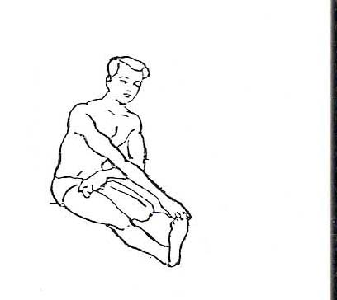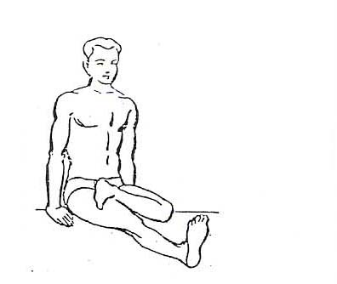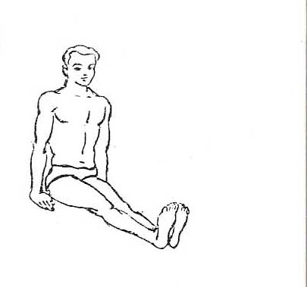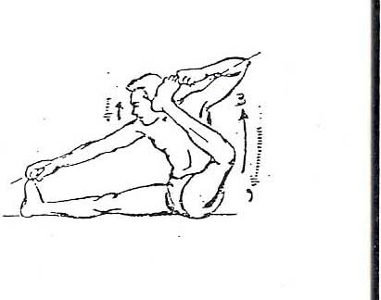
Taking the Asana Position:
Initial Position : Sitting Position
1) Bend the left leg at the knee and set it on the thigh of the right leg.
2) Hold the big toe of the left leg with the left hand, and toe of the right leg with the right hand.
3) Exhale, and while inhaling start lifting the left leg with the left hand pulling it up towards the left ear. Stabilize it at that point. Continue breathing smoothly.
The Asana Position :
Once the asana position is taken, smooth breathing should continue. When the one leg is lifted, the other leg and hand should be kept straight. The gaze should be fixed on the other end of the straight hand.
Releasing the Asana Position :
1) Inhale, and while exhaling lower the left leg on to the thigh of the right leg.
2) Restore both hands to their place.
3) Straighten the left leg and take the sitting position.
NOTE: Do this asana as mentioned above by taking up the right leg on the thigh of the left leg, bringing in relevant changes in the position.
Duration :
This latter asana exerts more strain than the former. It should also be maintained for thirty seconds to experience its benefits.
Internal Effects :
It has the same internal effect as the first type, except that the direction of the strain changes at the hip joints.
Precaution :
Persons with weak hip joints should not do this asana as it places great strain on those joints.
PADMASANA YOGAMUDRA (TYPE-1)
Introduction :
This asana is performed in padmasana position. There is a separate chapter on "mudra" in Yogashastra. But the word "mudra" in the name of this asana has nothing to do with the "mudra" included in Yogashastra. This is to be practiced simply as an asana.
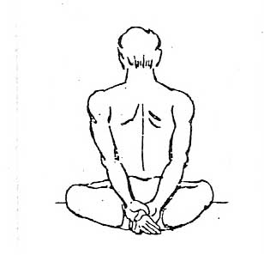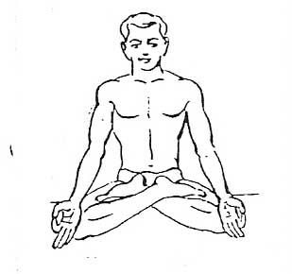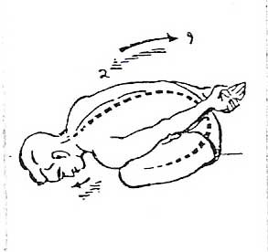

Taking the Asana Position: Initial Position : Padmasan Position
1) Inhale and take both hands behind the back keeping the palms facing out, and interlocking the thumbs. Keep both arms straight.
2) While exhaling, bend at the waist and rest the forehead on the floor. Continue breathing smoothly.
The Asana Position :
In this asana one has to sit in padmasan and bend from the waist fully. In this process, it is expected that the abdomen gets folded; however, in order to get the abdomen folded properly, one should try to set the forehead on the ground away from the body. Once bent over, continue breathing smoothly. After some practice, while bending from the waist, keep the back bone straight to experience the full benefits. After taking the position, try to relax into it.
Releasing the Asana Position :
1) Exhale and while inhaling, come up straight from the waist.
2) Restore the hands to the knees and take dhyana mudra.
Duration :
It should be held at least for one minute to get its benefits. After sufficient practice, this duration can be extended up to five minutes (but not beyond that).
Internal Effects :
As the belly gets folded in this asana, there is tremendous pressure on intestines, liver, spleen, certain glands, etc., and this pressure improves their functioning and removes digestive system problems and constipation. This asana is also used to awaken the kundalini shakti which, will require prolonged practice.
Precaution :
One should exercise caution while bending from the waist. The bending process should be slow and should paired with exhalation, or else one may suffer from air or gas accumulation in the belly. Those with back problems should practice this asana only after consulting a yoga expert.

PADMASANA YOGAMUDRA (TYPE-2)
Introduction:
This asana differs from the earlier one, only in the position of the hands. However, this version may be more challenging than the former. It is a more advanced state and naturally more beneficial. One should first practice type-1 and then move on to type-2.
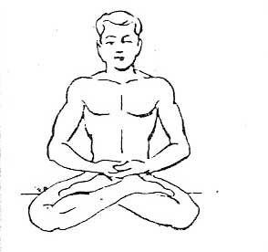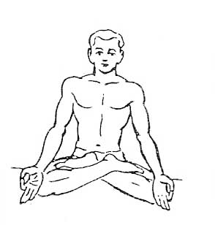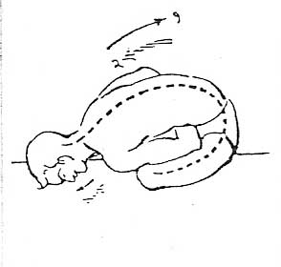
Taking the Asana Position:
Initial Position : Padmasana Position
1) Inhale, and while exhaling, set both palms near the belly below the navel, with the body resting on the heels of the legs. Keep the right palm on top of the left palm. Keep the fingers close together.
2) While exhaling, bend from the waist and place the forehead on the ground. Once fully bent over, continue breathing smoothly.
The Asana Position:
The position of this asana is the same as type -1, except for the position of the hands. Here, both palms are placed at the navel first. Then, while bending forward, the elbows are kept erect and close to the ribs.
Releasing the Asana Position:
1) Exhale, and while inhaling, come back up by bending from the waist.
2) Keep the hands on the knees and take up dhyana mudra.
Duration:
It is desirable to maintain this asana at least for one minute to experience the expected benefits. After prolonged practice, the duration can be increased up to five minutes.
Internal Effects:
Due to the placement of the palms at the navel, there is more pressure on the belly. This increased pressure multiplies the benefits of the earlier asana.
Precaution :
The same as mentioned for type-1. This asana should be done after good practice of type-1.
VAKRASANA (TYPE-1)
Introduction:
This asana is designed to twist the spine to the right and left side in its erect position. The spine is made up of highly elastic joints and can be moved in most any direction. However, in day-to-day life, it does not have side movements, and therefore, this asana can help in keeping the spine healthy.
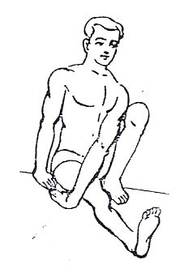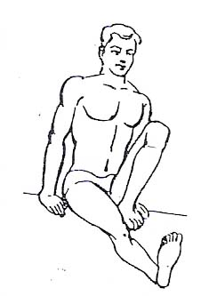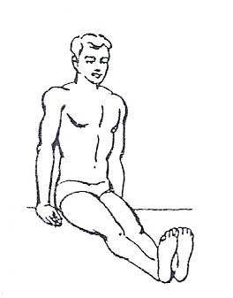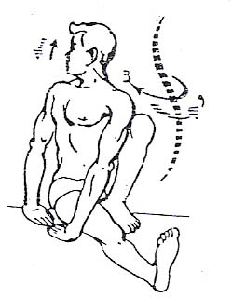
Taking the Asana Position:
Initial Position : Sitting Position
1) Bend the left leg at the knee and place its heel near the thigh. Keep the sole of the left foot flat on the floor and the thigh and knee touching the chest.
2) Place the left hand in front of the right hand so that the fingers point towards each other and the palms remain flat on the floor.
3) Now turn the neck and the trunk to the right, twisting the spine and looking back over the shoulder. Continue breathing smoothly.
The Asana Position:
In this asana the spine is to be kept straight. The base of the spine and the hips must be on the floor and stabilized. Then, with the support of the neck and shoulders, twist the upper vertebrae to the right. At the same time, the standing knee should be kept close to the chest. Along with the neck, the gaze should also be turned to the right side and stabilized in that direction. The chest should be open and shoulders relaxed and level.
Releasing the Asana Position:
1) Turn the neck to the front.
2) Restore the hand to its place.
3) Straighten the left leg and take the sitting position.
NOTE: Following the same process, practice this asana with the right leg folded.
Duration:
This asana should be retained for a minimum of two minutes on each side. With more practice this duration can be increased to six minutes.
Internal Effects:
The elasticity of the spine increases as it gets twisted in the erect position. Along with the spine, the belly and other internal organs also get twisted and receive the desired strain. It also has a very good effect on the spinal cord and improves its function.
Precaution:
Maintaining the asana with bearable strain, it should be released as indicated above. Persons having spinal column complaints should do this asana after consulting a yoga expert.

VAKRASANA (TYPE-2)
Introduction:
This is the advanced stage of vakrasana. Here the spine is twisted with the support of the knee and the shoulder, and hence involves more strain.
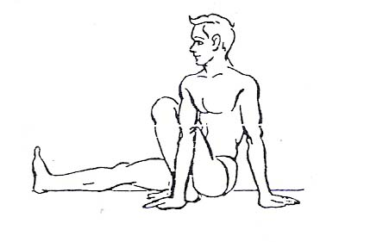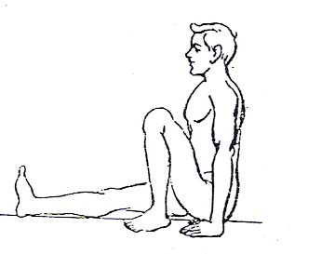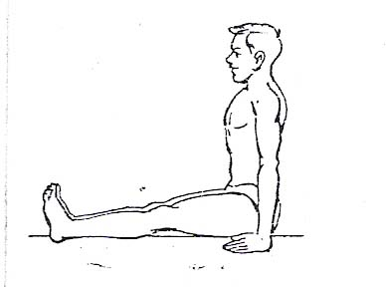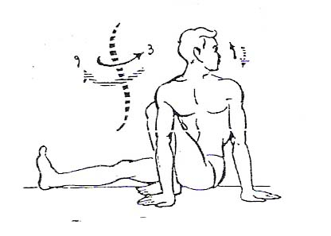
Taking the Asana Position:
Initial Position : Sitting Position
1) Bend the left leg at the knee and place it near the thigh of the right leg, sole and heel of the foot on the ground.
2) Place the right hand on the other side of the folded knee of the left leg and beside the left hand. Fingers should face in the opposite direction. There should be a distance of one foot between the two hands.
3) Press the standing left knee with the right arm and shoulder, and twist the neck to the left. Fix the gaze also in the same direction and continue breathing normally.

The Asana Position :
In vakrasana (type-1) the spine is twisted only with the help of the shoulders. Here the shoulders, the knee and the hands are placed in such a way that there is more pressure on the spine. Everything else is the same as in type- 1.
Releasing the Asana Position:
1) Turn the neck and the gaze to the front.
2) Restore the right hand to its place and turn the palm of the left hand.
3) Straighten the left leg and take the sitting position.
NOTE: Perform this asana on the other side, adapting as needed.
Duration :
It should be maintained for two minutes on each side to have the expected benefits. With practice, it can be maintained up to six minutes.
Internal Effects:
All the results of vakrasana type-1 are felt more prominently here.
Precaution:
The same as mentioned for the former.

ARDHA MATSYENDRASANA
Introduction :
It was Matsyendra rishi who designed and practiced this asana, and hence the name matsyendrasana. This asana in its original form is difficult to practice, which is why it was simplified later. The simplified form is called "ardha matsyendrasana'. After sufficient practice of this asana, it becomes possible to practice matsyendrasana.
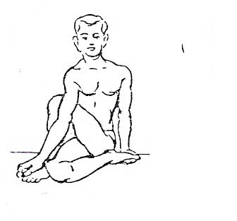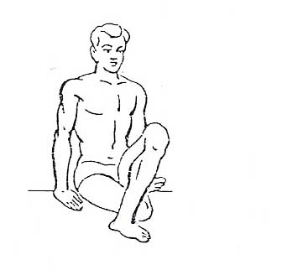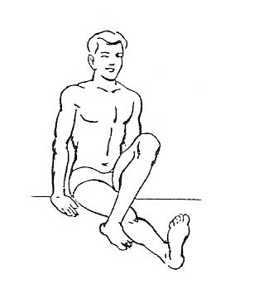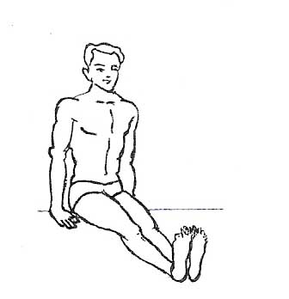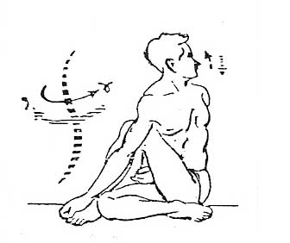
Taking the Asana Position:
Initial Position : Sitting Position
1) Bend the left leg at the knee and place it on the other side of the right knee. The knee should point upward.
2) Bend the right leg at the knee and fold it fully on its side.
3) Cross the right hand over the left leg and hold its big toe.
4) Twist the shoulders and the neck to the left as much as possible. Encircle the waist with the left hand, palm facing out. Turn the neck also to the left and continue breathing smoothly.

The Asana Position :
While taking the right hand over the knee of the left leg, keep the right arm touching the standing knee of the left leg and keep the downward part of the right arm parallel and very close to the knee. The folded left leg is pressed by the right arm in order to twist the trunk to the left, while exhaling. At this point do not try to sit over the folded right leg. Keep the folded right leg free. While twisting the trunk to the left, lift and open the chest. Straighten the spinal column and the neck, and then turn to the left as much as possible. This twisting process is further enhanced by the encircled left hand around the waist. Once the final position is attained, the breath should continue smoothly.
Releasing the Asana Position:
1) Turn the neck and the gaze to the front.
2) Restore the hands to their place.
3) Straighten the right leg.
4) Restore the left leg to the front and take the sitting position.
NOTE: Do this asana on the opposite side, with necessary relevant changes in taking and releasing the asana.
Duration:
However this asana is practiced, it should be maintained for two minutes on each side. After advancing to the full duration in that practice, try holding the ideal position and stabilize it for two minutes. After a good deal of practice, it can be held for five minutes on each side.
Internal Effects:
This is the advanced stage of vakrasana. Naturally, all the advantages of that asana are experienced more prominently in this version. It has favorable effects on constipation and loss of appetite.
Precaution:
The same as for vakrasana.

SHARANAGATA MUDRA
Introduction:
Though the suffix "mudra' is included in the name, it is going to be treated as an asana. The desire of surrendering and becoming one with the almighty God is the central theme of this asana.
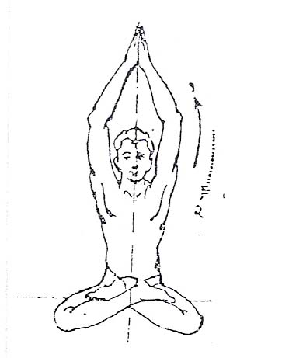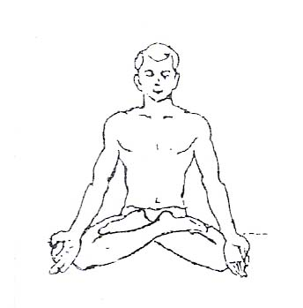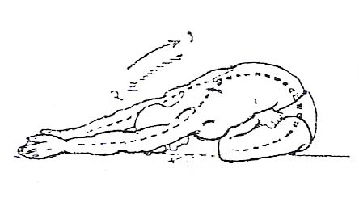
Taking the Asana Position:
Initial Position : Padmasana Position
1) Exhale, and while inhaling raise the hands upward from the sides and join the palms.
2) Exhaling, bend from the waist and touch the forehead to the floor, keeping the arms straight. After taking the final position, continue breathing smoothly.
The Asana Position :
As in yogamudra, the abdomen gets folded here as well. Further, attempt should be made to have this fold as complete as possible. The outstretched arms should be kept as straight as possible. Keep the knees resting on the floor and the spinal column straight. Place the forehead on the floor as far from the crossed legs as possible. While outstretching the hands, keep the arms touching the ears. Breathe normally.
Releasing the Asana Position :
1) Exhale, and while inhaling start raising the arms, neck and the trunk, and straighten up from the waist. Keep the hands outstretched above the head.
2) While exhaling, bring both hands down by the sides and take dhyana mudra.
Duration:
This asana should be maintained at least for one and a half minutes to have the desired benefits. After practice, this duration can be increased to three minutes.
Internal Effects:
The results of yoga mudra (type-1) are experienced in this asana.
Precaution:
The same as stated for the "yoga mudra'.
VAJRASANA
Introduction:
Like padmasana, this is also the asana for meditation. One can sit comfortably for a prolonged period in this asana. pranayama can also be practiced in this asana. Though its name is Vajrasana, it has nothing to do with the weapon called "VAJRA'.
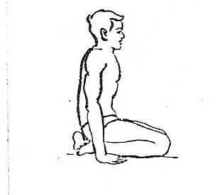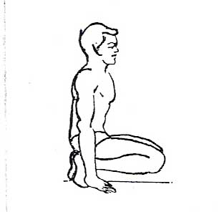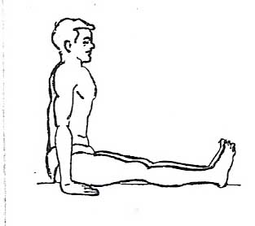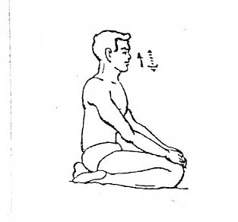

Taking the Asana Position:
Initial Position : Sitting Position
1) From sitting come onto the toes and then kneel on the floor
2) Place the tops of the feet onto the floor, keeping the big toes touching and separate the heels.
3) Sit on the pit formed by the parted heels
4) Place the palms on the knees.
The Asana Position:
It is important to keep the spine, the neck and the head, upright in one straight line in this asana. Keep the gaze fixed straight ahead. Don't put any pressure on the hands. The whole weight of the body is supported by the spine. Continue breathing smoothly once the final position is attained.
Releasing the Asana Position:
1) Remove the palms from the knees and bring them to the sides.
2) Lift the buttocks off the legs and bring the toes in the erect position
3) Come onto the toes. Extend the right leg and straighten it followed by the left.
4) Take the sitting position.
Duration :
After a little practice, this asana can be maintained for a long time. In the daily routine it should be kept for five minutes to experience its benefits. With more practice it can be kept for three hours.
Internal Effects:
Along with the body, the mind also gets stabilized in this asana. Hence, it is preferred for meditation and concentration. This asana is also found to be good for pranayama.
The special fold of the legs forms one bandha in this asana. Consequently the blood circulation in the lower body is controlled. For this reason this asana is recommended after shirshasana.
Precaution :
People with stiff joints, or those whose movements have become difficult, should practice this asana with a lot of care. They should practice this asana after getting the joints warmed up and relaxed.
VAJRASANA YOGAMUDRA (TYPE-1)
Introduction:
We have already seen padmasana yogamudra (type-1) and here is vajrasana yogamudra (type-1). The difference between the two lies in their initial positions, padmasana and vajrasana respectively. Regarding the asana position, the internal effects are the same.
Duration:
As this asana is simple, it can easily be maintained for two minutes and even more.
VAJRASANA YOGAMUDRA (TYPE-2)
Introduction:
Padmasana togamudra (type-2) which has been described earlier, and the present vajrasana yogamudra (type-2), are the same in their asana position, internal effects, etc., except their initial position.
Duration:
This asana should be maintained for one and half minute to have the expected results.
PASHCHIMOTTANASANA (ARDHA)
Introduction :
Ardha pashchimottanasana is not an independent asana. But since paschimottanasana (full) is difficult to practice, paschimottanasana (ardha) is designed to prepare the body to take the full position later. This has not been mentioned in any yoga book.
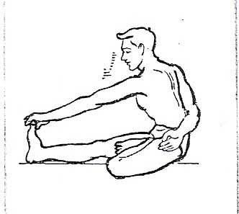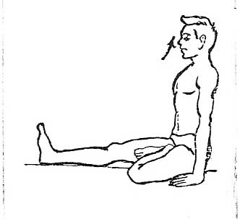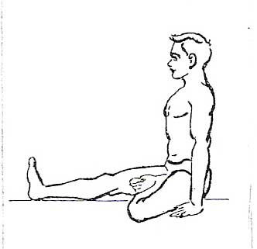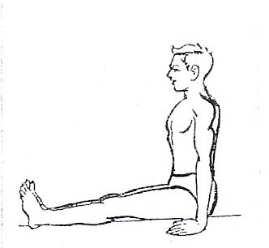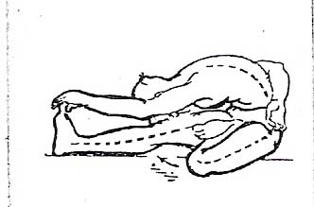
Taking the Asana Position:
Initial Position : Sitting Position
1) Fold the left leg at the knee and place the heel of the left foot near the thigh of the right leg.
2) Only inhale.
3) While exhaling, hold the big toe of the right foot with the left hand and encircle the right hand round the waist.
4) Exhale completely, and bend downwards and touch the forehead to the knee. Don't allow the knee to come up. Continue breathing smoothly.
The Asana Position:
The process of downward bending is the same as in pashchimottanasana (full) the description of which will follow. In this Asana one leg is folded and the calf and the thigh are kept to the floor.
Releasing the Asana Position :
1) Exhale, and while inhaling, start raising the head.
2) Restore both hands to their place.
3) Straighten the left leg and take the sitting position.
NOTE: Practice this asana by folding the right leg, and making relevant changes.
Duration :
Initially, even if it is maintained for thirty seconds, one experiences the benefits. Of course, after practice, it should be increased to four to five minutes.
Internal Effects:
Advantages of pashchimottanasana (full) are realized to some extent. Basically this asana prepares the body for pashchimottanasana (full).
Precaution :
While bending downward, there is the possibility of the knees and thighs being raised, and this should be avoided.

PASHCHIMOTTANASANA (FULL)
Introduction :
The front side of the body is called east side, while the back one is called west side. In this asana complete back side, i.e., the west side, right from the heels to the forehead, gets stretched and therefore, it is called "pashchimottanasana'.
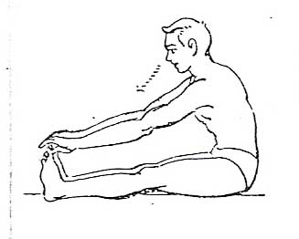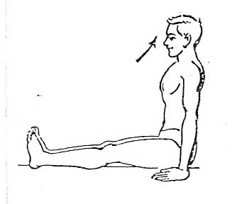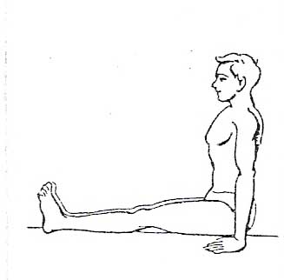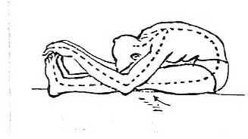

Taking the Asana Position:
Initial Position : Sitting Position
1) Only inhale.
2) Exhale, and hold the big toes of both the feet with both the hands.
3) In exhaled state bend downward and rest the forehead on the knees. Continue breathing smoothly.
The Asana Position :
After bending down, keep the heels, calves, thighs completely touching to the floor, keeping the spine straight, rest the forehead on the knees and continue smooth breathing. Try to rest the elbows on the floor. Since here the abdomen gets completely folded, it becomes necessary to bend only after complete exhalation. One should bend downward as much as one's body permits and then try to stabilize at that point, keeping the breathing smooth. Do not try to raise the knees in order to get the forehead on to the knees. After taking the position, relax the whole body and automatically the head, shoulder, chest will come down owing to their weight and relaxation.
Releasing the Asana Position:
1) Exhale, and inhaling start raising the head.
2) Restore the hands to their place and take up the sitting position.
Duration :
One finds it difficult to take up this asana initially. But with practice and patience it can be maintained for thirty seconds. Later one certainly succeeds in having the final position and the duration is also increased to three minutes.
Internal effects
Since the nadis and other tissues of the whole of the west side of the body get stretched, they get purified and their functioning is greatly improved. At the same time, the muscles of the front side get contracted and there is pressure on the lungs, intestines and other internal juice producing glands. As a result of this their functioning is also improved. It is very useful in setting right the troubles concerning the lumber part of the spinal cord and the digestive system. Further, there is very sensitive part in our body known as kundalini lying in dormant stage. This asana is supposed to activate it.
Precaution:
It has been said that this asana is useful for the troubles of the spine. Yet people suffering from such troubles should practice this asana only after consulting some yoga experts.

* * *

